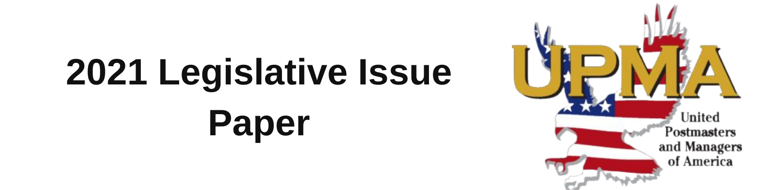

The United States Postal Service at a Glance:

Service: Package volume grew by nearly 1.2 billion pieces, or 18.8 percent, compared to last year. First Class mail volume declined 2.3 billion pieces, or 4.2 percent.

Election Mail: USPS prioritized processing of Election Mail during the 2020 general election, significantly improving timeliness over the 2018 mid-term election even with significantly increased volumes of Election Mail in the mailstream, according to USPS OIG.

Finances: The USPS is the only entity—public or private—required to fully prefund its retiree healthcare benefits. In FY2020, USPS revenues increased $2 billion.

Covid-19: From the beginning of the pandemic, the USPS was able to modify its operations to mitigate the impact of the pandemic and meet its universal service obligation. As essential workers, UPMA members made sure that Post Offices were open and operating.

UPMA Priority Issues in the 117th Congress:

Comprehensive Postal Reform
UPMA Supports H.R. 3076, the Postal Service Reform Act of 2021—Rep. Carolyn Maloney (D-NY) and Rep. James Comer (R-KY) and S. 1720 – Senator Gary Peters (D-MI) and Senator Rob Portman (R-OH)

The House Oversight & Reform Committee has passed bipartisan postal reform legislation. Moving this bipartisan legislation is urgent. UPMA strongly supports this legislation and believes it is essential to addressing long-term fiscal and governance challenges facing the USPS. H.R.3076 would make these changes:
- Eliminates the current pre-funding mandate for USPS healthcare costs
- Requires all postal retirees to enroll in Medicare (waives any penalty and provides hardship releif)
- Requires preservation of six-day delivery
- Provides flexibility to the Postmaster General (PMG) to utilize ground transportation for cost efficiency and flexibility
- Requires progress reports to Congress on the PMG’s implementation of his reform plan.
We also strongly support the following provisions as part of larger postal reform:
- Reforming the USPS governance structure to improve decision making
- Modernizing and improving USPS business practices
- Making essential investments to modernize facilities and the vehicle fleet
Maintaining an Independent United States Postal Service
UPMA supports H.Res.47

Rep. Stephen Lynch (D-MA) introduced House Resolution 47, which states: “That it is the sense of the House of Representatives that Congress should take all appropriate measures to ensure that the United States Postal Service remains an independent establishment of the Federal Government and not subject to privatization.”

Postal Service Improvement Act
UPMA supports H.R. 3077

UPMA believes postal services are a critical necessity for all communities and small and large businesses After the COVID-19 pandemic USPS proved their value to the election and American people. This bill ensures USPS will be able to transparently track ballots of any citizen who chooses to vote by mail with a bar code. Further, recognizing the sacrifice of USPS employees during the pandemic, USPS employees would be eligible for paid sick leave plans consistent with other federal employees and contractors.

Fair Treatment of Civil Service Retirement System (CSRS) Annuitants—WEP/GPO
UPMA supports H.R. 82—Rep.Davis (R-IL), H.R. 2337—Rep. Neal (D-MA), and S. 1302—Senator Brown (D-OH)

More than three decades ago, two provisions were enacted that unfairly penalize CSRS annuitants: the Windfall Elimination Provision (WEP) and the Government Pension Offset (GPO).

The WEP is a one-size-fits-all mechanism that reduces the Social Security benefits of workers who also participate in pension plans from employment not covered by Social Security, such as CSRS. The GPO reduces a CSRS retiree’s Social Security spousal or survivor benefits by an amount equal to about two-thirds of the CSRS annuity. All three bills would make a significant impact on the retirement security of retired Postal Service employees and current employees who are covered by CSRS.

Remaining the Delivery Partner of choice for American Small Businesses

Small businesses in particular rely on their postal services to reach customers and maintain cost competitiveness. The USPS is a major supplier of cost-effective business solutions, and makes it possible for small business to deliver goods, products, and services to customers across the country and around the globe. UPMA supports the USPS’s efforts to strengthen and increase its market share in this phase of the business model they have adopted.

Other Priority Issues for UPMA in the 117th Congress Include:
- H.Res.108—Rep. Steven Lynch (D-MA): Supporting frontline and essential postal workers
- S.145 and H.R. 695, the USPS Fairness Act—Senator Steve Daines (R-MT) and Rep. Peter DeFazio (D-OR): Repeals the requirement that the USPS annually prepay future retirement health benefits
- H.R. 3287 and S.1663, the USPS Shipping Equity Act—Rep. Jackie Speier (D-CA), Rep. Dan Newhouse (R-WA), and Senator Jeff Merkley (D-OR): allows shipping of alcoholic beverages.

