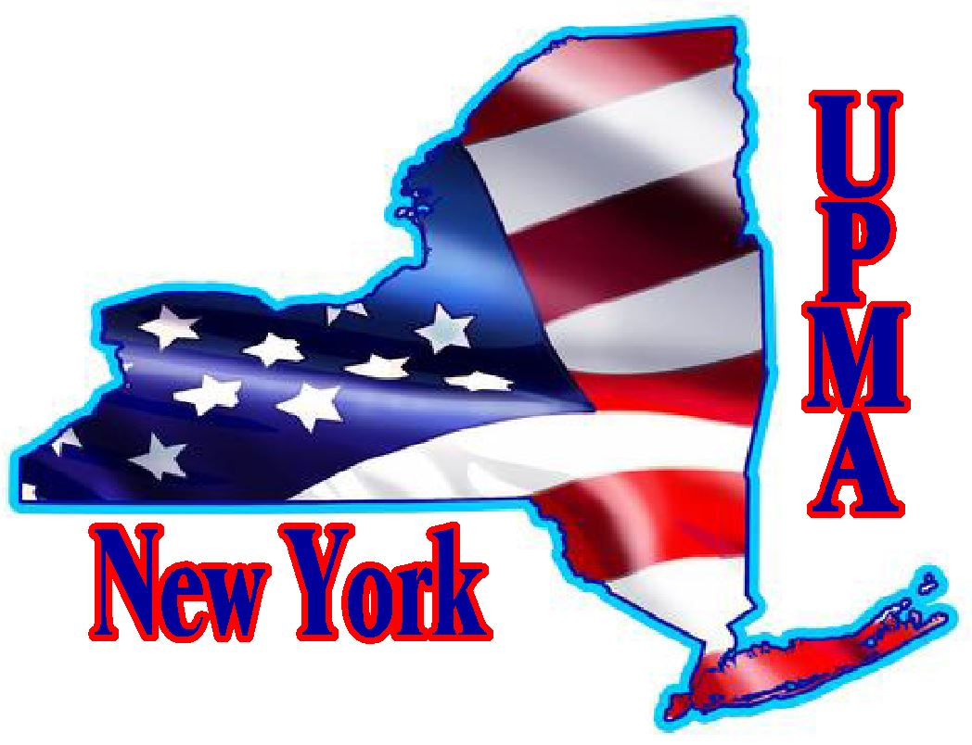 | Frank & Helen Burger Scholarship  SCHOLARSHIP APPLICATION  NEW YORK CHAPTER UPMA  2025

Student’s Full Name: _____________________________________________________________________________________
Student’s Address: _____________________________________________________________________________________
City: _________________________ State: ______________ Date of Birth: _________ Gender: ______
Phone Number: Home: _______________________ Cell: ___________________________
Email Address: ___________________________________________________________________________
College or Trade School You Plan to Attend: ______________________________________________________________________
Have you been accepted? ________ Attach copy of acceptance
Name of High School: _____________________________________________________________________________________
Address: _________________________________________________________________________________
Mother’s Full Name: ________________________________ Father’s Full Name: ____________________________________
Parent or Grandparent Who is a Current UPMA Member: ___________________________________________________________
Address: __________________________________________________ Phone:__________________
Relationship to Student: Mother: _____ Father: _____ Grandparent: _____
Postmaster: _____ Office/s: _________________________________ Zip: ____________
Postmaster Retired: _____ Office/s: _________________________________ Zip: ____________
This scholarship is only available for children or grandchildren of current or retired Postmasters.
Please note: Children and grandchildren of associate members are not eligible for this scholarship.

THIS APPLICATION FORM MUST BE ACCOMPANIED BY:
- Students high school transcript
- College or Trade School acceptance letter
- Personal resume of scholastic activities, extracurricular activities, sports, employment history, community service, clubs, and positions held, and awards or honors received.
- Applicant’s personal statement. Please write a statement in which you discuss a personal experience or achievement in your life. Describe how it relates to your aspirations for the future.
- Two letters of recommendation
- A photo of the student that will be published in the Empire State UPMA magazine
.Eligible student applicant must be a high school senior who will graduate in December 2024 or a high school senior who will graduate in May/June2025.
APPLICATION DEADLINE: Must be postmarked by April 1, 2025
Send completed application to: Carol Commisso, 11 Ambassador Dr., Victor, NY 14564
Email any questions to: ccommisso12@gmail.com

